**Kubernetes Multi-Tenant Project**

**Step 1: Check if Any Worker Node is Ready**

* kubectl get nodes

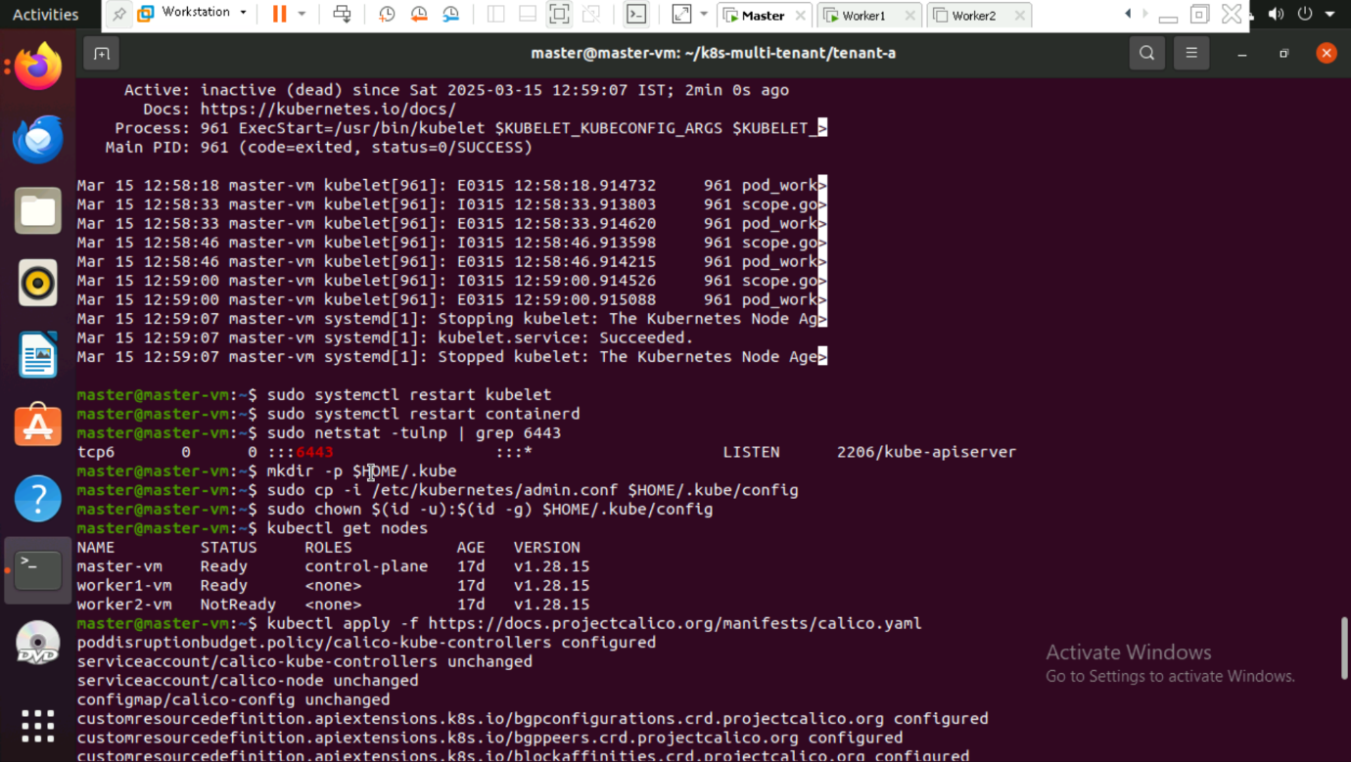

**Step 2: Install Calico for Networking**

* kubectl apply -f <https://docs.projectcalico.org/manifests/calico.yaml>

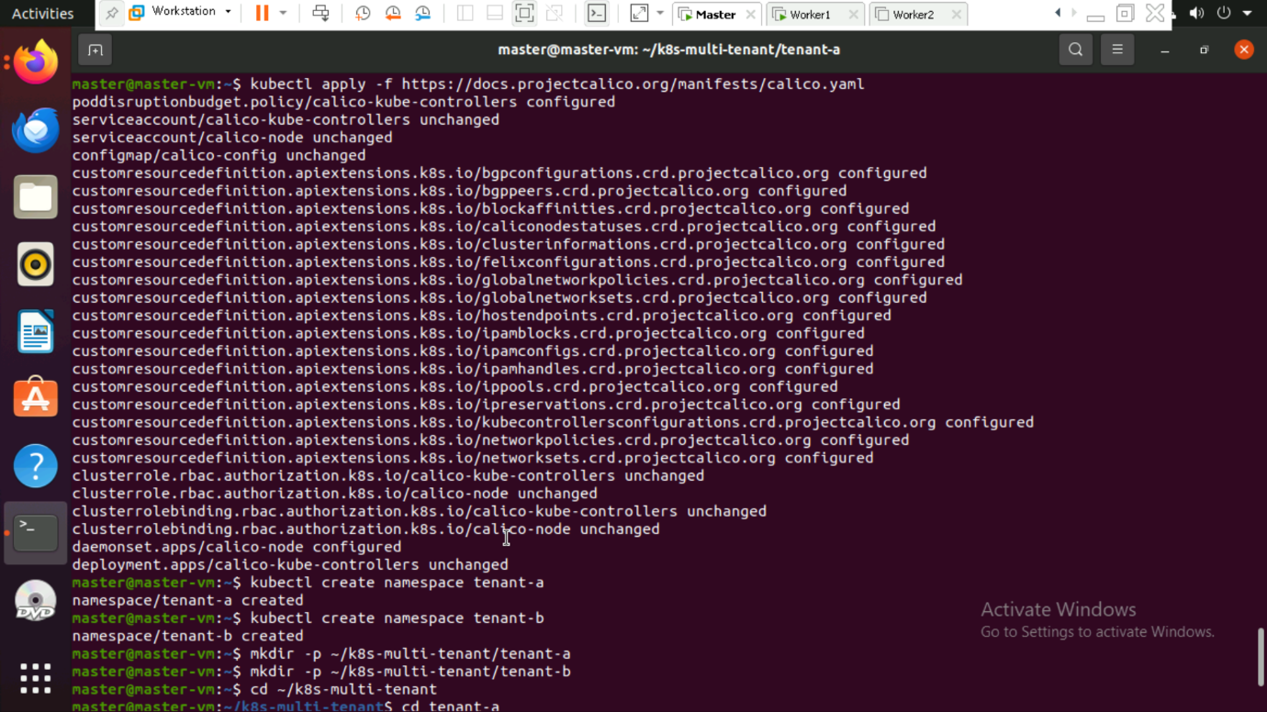

**Step 3: Create Namespaces for Tenants**

- kubectl create namespace tenant-a

- kubectl create namespace tenant-b



**Step 4: Create Folder Structure for YAML Files**

* mkdir -p ~/k8s-multi-tenant/tenant-a
* mkdir -p ~/k8s-multi-tenant/tenant-b
* cd ~/k8s-multi-tenant

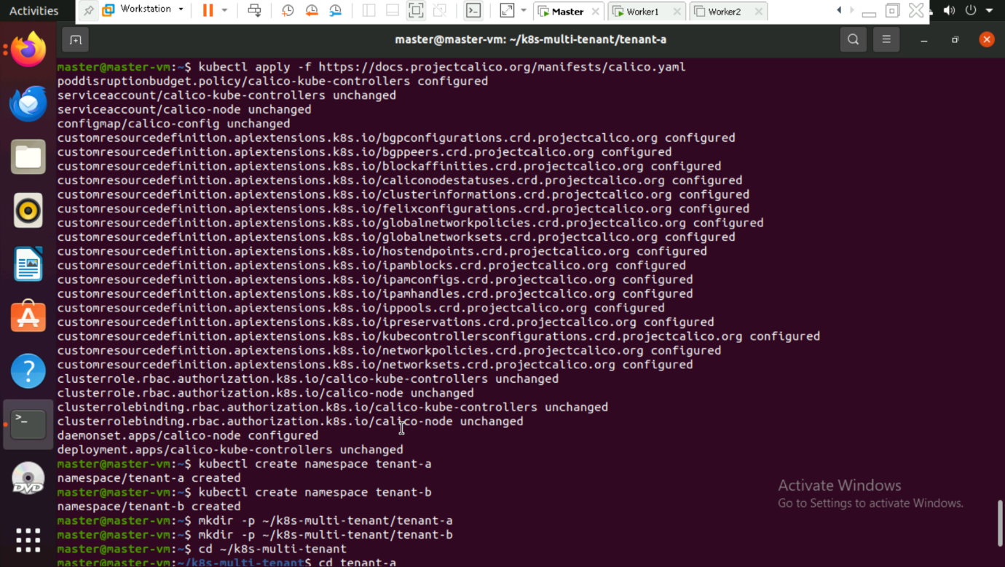

**Step 5: Create Deployment and Service for Tenant A and apply the configuration.**

* kubectl apply -f tenant-a/tenant-a-app.yaml

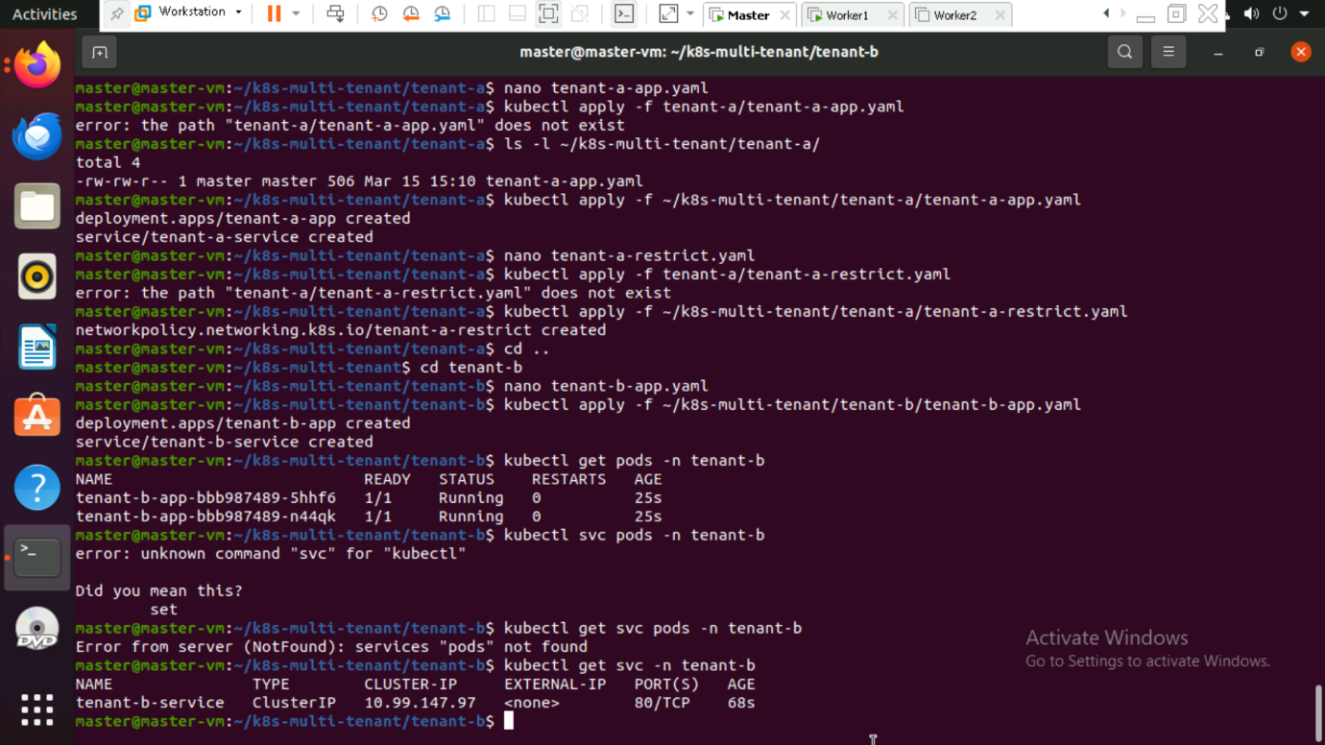

**Step 6: Restrict Network Access for Tenant A and apply the network policy.**

* kubectl apply -f tenant-a/tenant-a-restrict.yaml



**Step 7: Create Deployment and Service for Tenant B and apply the deployment.**

* kubectl apply -f tenant-b/tenant-b-app.yaml

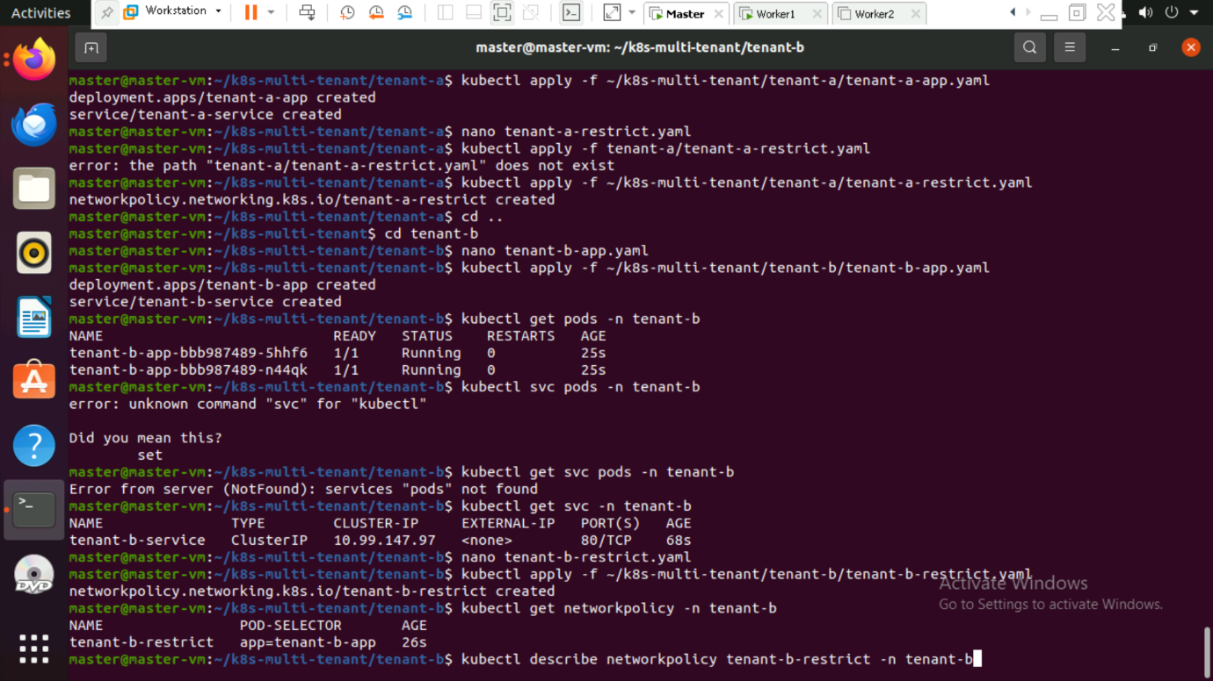

Verify the Deployment

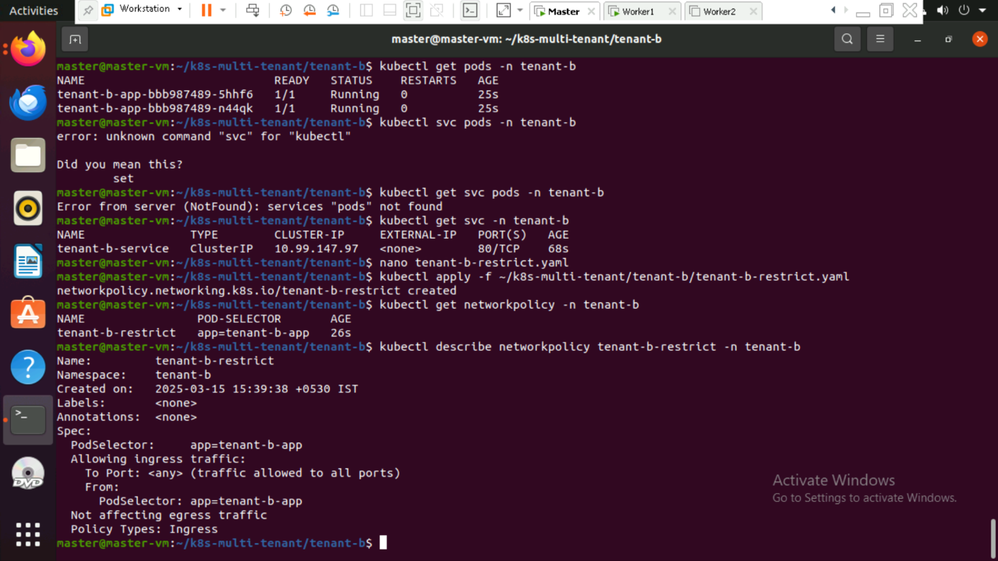



**Step 8: Restrict Network Access for Tenant B and Apply the network policy.**

* kubectl apply -f tenant-b/tenant-b-restrict.yaml



**Step 9: Verify Network Policy**

* kubectl get networkpolicy -n tenant-b
* kubectl describe networkpolicy tenant-b-restrict -n tenant-b



**Step 10: Test Tenant Isolation**

* docker pull alpine

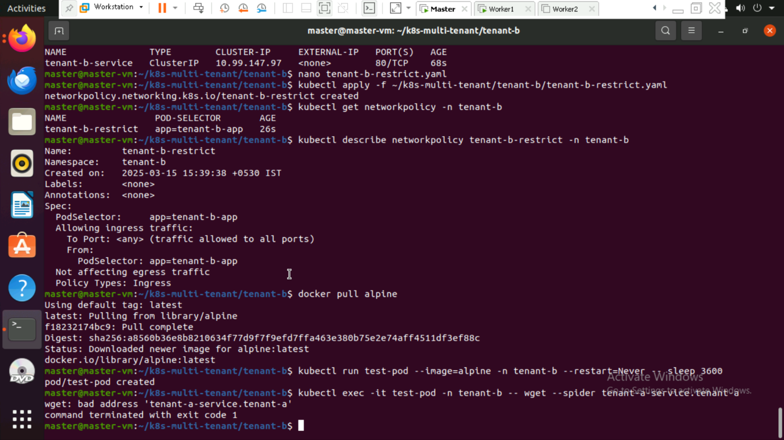

* kubectl run test-pod --image=alpine -n tenant-b --restart=Never -- sleep 3600
* kubectl exec -it test-pod -n tenant-b -- wget --spider tenant-a-service.tenant-a

